University of Azad Jammu and Kashmir

Name: Saghar Sarfaraz

Roll No: 2024-CET-31

Subject: Graphics Designing

Department: Software(CET)

Submitted To: Mam Fatima Khawaja

Question

Design a low-fidelity wireframe for a mobile app login screen.
Your wireframe must show: app logo/title, username or email field, password field, login button, forgot password option, and sign-up option.
Also, write 3-4 lines explaining how your design improves user experience.
Instructions: Use simple boxes and labels only. Keep the layout readable, clear, and user centered.
(CLO-3)

Ans: A log page with clear and simple design. This design is very simple because user easy to understand it.

Design

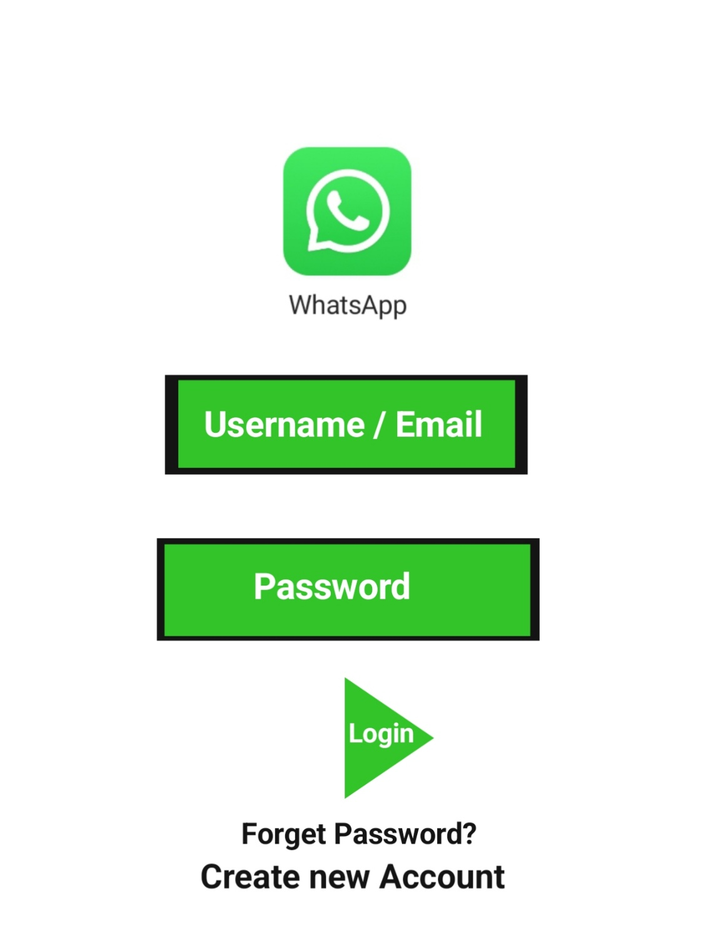

Explanation:
- I used to create the design very simple because it is easy to understand.
- I used the logo at the top user easy to understand the app.
- I used bold font to make it easy to understand the text of image.
- I used green color in the design because the logo is green and the green is the Favorite color of many people.

